|  |  |
| --- | --- |
| Name: |  |

**5.3: Optics & Photons**

**Part 1: Bending Light Simulation**

To open the simulation, click on the link in Canvas labeled [*Bending Light Simulation*](https://phet.colorado.edu/sims/html/bending-light/latest/bending-light_en.html).  
After opening the simulation, make the following settings:

* Click on the “More Tools” tab
* Laser View: Ray (default)
* Click on red dot to turn laser on.
* Check the “angles” and the “normal” checkbox.
* Set the upper material to the “air” setting and the lower material to “water.” **Note: Use the drop-down box to select the material, not the slider control.**

Select a random wavelength by adjusting the slider and record the wavelength, color, speed, and index of refraction in the materials listed the table below. Do not use the same wavelength as your neighbor or the instructor’s example. Change the bottom material to water when you are ready to measure the speed of light in glass and its index of refraction.

For the calculated speed, divide the index of refraction into 1 to get the answer in units of *c*. Example: if the index of refraction is 1.284, the speed of light in units of *c* is $\frac{1}{1.284}c=0.779 c$. Keep 3 digits after the decimal.

|  |  |  |  |  |  |
| --- | --- | --- | --- | --- | --- |
| Wavelength | Color | Material | Speed  (w/ meter) | Index of Refraction | Speed (Calculated) |
|  |  | Air |  |  |  |
| Water |  |  |  |
| Glass |  |  |  |

Move the light source to an angle of incidence between 20° and 40°. It should be different than your neighbors and the instructor’s example. Record it below in the Angle of Incidence field in the table on the next page. Keep it the same for the next three measurements.

Continued on the next page.

Set the top and bottom materials as indicated below and record the angles listed.

|  |  |  |  |  |
| --- | --- | --- | --- | --- |
| Top Material | Bottom Material | Angle of Incidence | Angle of Reflection | Angle of Refraction |
| Air | Water |  |  |  |
| Air | Glass |  |  |
| Glass | Air |  |  |

Answer the following questions based on your results above. Place an X in the highlighted box next to your answer choice.

|  |  |  |
| --- | --- | --- |
| When light slows down on entering a new material, the light ray | | |
|  | a | bends toward the perpendicular |
|  | b | does not bend at all |
|  | c | bends away from the perpendicular |
|  | d | does not bend but changes wavelength |

|  |  |  |
| --- | --- | --- |
| When light speeds up on entering a new material, the light ray | | |
|  | a | bends toward the perpendicular |
|  | b | does not bend at all |
|  | c | bends away from the perpendicular |
|  | d | does not bend but changes wavelength |

Examples of bending

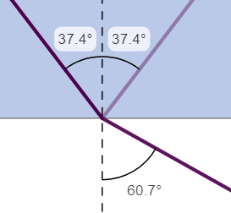 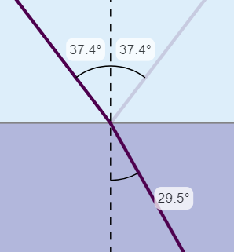

Light bending away from the perpendicular; light bending toward the perpendicular.

|  |  |  |
| --- | --- | --- |
| When going from air to glass, red light always | | |
|  | a | slows down more than violet light. |
|  | b | slows down the same amount as violet light. |
|  | c | slows down less than violet light. |

|  |  |  |
| --- | --- | --- |
| When going from air to water or glass, the more light slows down, | | |
|  | a | the more it bends |
|  | b | the less it bends |
|  | c | the bending is the same for all speed changes |

**Part 2: Calculate the index of refraction for a given material.**

**The speed of light in a vacuum is the same for all frequencies (and colors) of light (2 $.998×{10}^{8}\frac{m}{s}$).**

Find your name in the table below and use the speed of light in the material listed for you. Then calculate the index of refraction for that material using the formula below. Round your answer to 3 places to the right of the decimal (which is 4 significant figures).

|  |  |  |
| --- | --- | --- |
| **Student** | **Material** | **Speed of Light in the Material (*v*)** |
| Baca, Jacob | benzene | 1.990 x 10^8 m/s |
| Bltom, Biniam | carbon disulfide | 1.843 x 10^8 m/s |
| Brion, Matthew | carbon tetrachloride | 2.053 x 10^8 m/s |
| Clevenger, Christopher | ethanol | 2.204 x 10^8 m/s |
| Eldridge, Marcus | glycerin | 2.037 x 10^8 m/s |
| Higgins, Sean | diamond | 1.240 x 10^8 m/s |
| High, Parker | fluorite | 2.092 x 10^8 m/s |
| Jimenez, Serena | crown glass | 1.974 x 10^8 m/s |
| Mejia, JeffreyLousie | flint glass | 1.807 x 10^8 m/s |
| Mohibi, Hasibullah | polystyrene | 2.013 x 10^8 m/s |
| Poor, Travis | plexiglas | 1.987 x 10^8 m/s |
| Powell, Anniya | crystalline quartz | 1.943 x 10^8 m/s |
| Smith, Shawn | fused quartz | 2.058 x 10^8 m/s |
| Tanner, Anthony | sodium chloride | 1.943 x 10^8 m/s |
|  | zircon | 1.560 x 10^8 m/s |
|  | ruby | 1.703 x 10^8 m/s |
| Instructor | salt | 1.972 x 10^8 m/s |

Substitute your speed and the speed of light in vacuum into the formula below and calculate the index of refraction for your assigned material.

Reminder: to get proper accuracy to 4 significant figures, use

$c=2.998×{10}^{8}\frac{m}{s}$

|  |
| --- |
| $n=\frac{Speed of light in vacuum}{Speed of light in material}=\frac{c}{v}=\frac{\left(\right)}{\left(\right)}=$ |

Note: The speed units (m/s) will divide out of the calculation.   
**The index of refraction has no units; it is just a number**.

**Show your substitution and keep 4 significant figures in your answer.**

**Part 3: Total Internal Reflection**

When light speeds up on exiting a material, it bends outward away from the perpendicular. At a certain angle of incidence (called the critical angle), this makes the refraction of light impossible, and all the light reflects at the surface.

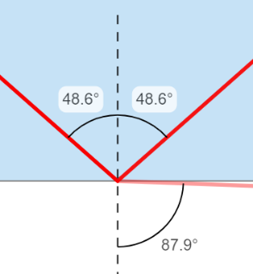To demonstrate this, return to your simulation and set the top medium to water and the bottom medium to air. Reset your wavelength to the same wavelength you were using before. Adjust the angle of incidence until the angle of refraction is just under 90º.

Take a screen shot and paste below (you can limit the image to just show the three angles as in the example at right).

Paste screenshot here.

Then make the angle of incidence just a tiny bit larger and the refracted ray should vanish, and all the light should be reflected at the interface. The second angle of incidence should be no more than 0.2 degree larger than the first screen shot setting for top grade.

Paste a similar screen shot showing the change.

Paste screenshot here.

Total internal reflection is a vital component of many new technologies, including fiber optic cables, for redirecting light without loss of intensity, and remote viewing applications such as surgery and surveillance.

**Part 4: The Photoelectric Effect**

We will do this part only if there is time. Listen for instructions.

Open the [Physics Aviary simulation of the Photoelectric Effect](https://www.thephysicsaviary.com/Physics/Programs/Labs/PhotoelectricEffect/).

* Click begin.
* Lower the voltage to zero.
* Record the default wavelength of light and the default intensity in the chart below.
* Clicking on the metal plate on the right cycles through 7 different metals. For each metal, indicate whether the light causes electrons to be emitted.

|  |  |  |  |
| --- | --- | --- | --- |
| Wavelength | Intensity (no units) | Metal | Electrons emitted? |
|  |  | Potassium |  |
| Platinum |  |
| Sodium |  |
| Silver |  |
| Cesium |  |
| Gold |  |
| Copper |  |

Look at a periodic table of the elements such as at this link:

[National Library of Medicine Periodic Table of the Elements](https://pubchem.ncbi.nlm.nih.gov/periodic-table/).

Each column of the period table aligns elements with the same number of valence electrons, which are electrons that reside at the outermost level from the nucleus and are available to take part in chemical reactions. The farther one goes to the right on the table, the harder it is to ionize, that is, it takes more energy to remove an electron.

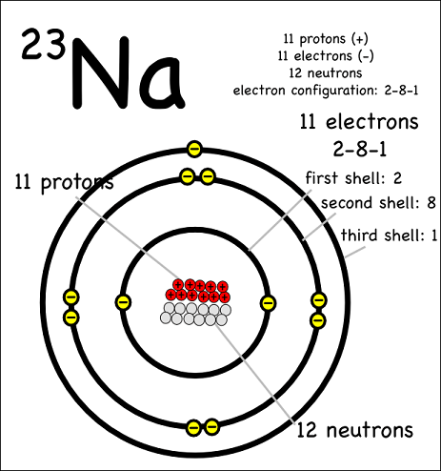Magnesium has more protons in its nucleus, so it takes more energy to remove an electron from magnesium than sodium, because the Coulomb force on the electrons is larger.

|  |
| --- |
| What do the metals that emitted electrons when hit by light have in common that might explain why they behaved differently than the other metals? |
|  |
| What other metal(s) on the list is in the same column as the elements that emitted electrons? |
|  |

Repeat the test performed above but change the metal to *sodium*. Gradually increase the intensity and observe if any electrons are emitted when only the light intensity increases. Keep this up until you reach the highest intensity (120).

|  |
| --- |
| State the result of this test. If electrons were eventually emitted, state the intensity of light that produced electrons. If no electrons were produced at even the highest intensity, state “No electrons at any intensity.” |
|  |

When performing these experiments around 120 years ago, scientists working with the electromagnetic model of light assumed that any metal could be made to emit electrons if a bright enough light was shined on it for long enough. However, tests like these proved it was not the case.

But calculations designed to replicate the blackbody radiation spectrum could only be made to work if it was assumed that the energy of light was *quantized*, that is, that the energy could only be some whole number multiple of a basic energy value. While they could see no reason that this should be true, it made the calculations work, which suggested that light might actually have this quantum nature.

Albert Einstein published a paper that stated the results of the photoelectric effect proved that light has a particle nature. He called the particles *photons* and asserted the energy of the photon was proportional to the frequency of the light. This is the equation *E = hf*, where *h* = Planck’s Constant. The following experiment will step you through how he arrived at this conclusion.

* Change the metal to *Cesium*.   
  Adjust the Brightness to 60.   
  Leave the voltage at 0.0 V.
* Set the Wavelength the first wavelength listed in the table below.
* Note that the frequency values were calculated using $f=\frac{c}{λ}$.

|  |  |  |  |  |
| --- | --- | --- | --- | --- |
| Wavelength (nm) | Frequency THz | Electrons emitted? (yes or no) | Voltage V  (see instructions) | Photon energy eV |
| 600 | 500.0 |  |  |  |
| 500 | 600.0 |  |  |  |
| 400 | 750.0 |  |  |  |
| 300 | 1000.0 |  |  |  |

*E = hf = $\left(4.14×{10}^{-15}\frac{eV}{Hz}\right)\left(500×{10}^{12} Hz\right)=$*

* Run the simulation for each wavelength. If no electrons are emitted, write the word *no* in the middle column of the table, enter 0 volts for the Voltage.
* If electrons are emitted, adjust the voltage to find the smallest voltage that will keep electrons from reaching the detector. Record that voltage.
* Calculate the photon energy for each frequency (provided in column 2) by multiplying the frequency by Plank’s constant ($h=4.14×{10}^{-15}\frac{eV}{Hz}$). The unit *eV* stands for *electronvolt*, which is the kinetic energy of an electron accelerated across a 1 volt potential difference.   
  Note that *THz* stands for 1 *TeraHertz*, which is 1 trillion *Hz* or 1012 *Hz*.

**Interpretation**

Electrons can be made to leave a metal’s surface if given enough energy. For Cesium, an electron must have a little more than 2 eV of energy to escape the electric attraction of the metal. (This is called the *Work Function* of the metal.) You can subtract 2 eV from each photon energy to get the approximate voltage needed to stop the electron. **Note: if your energy values do not support this, check with the instructor to find out what is wrong with your data.**

So what happens when a brighter light shines on the metal? We know there should be more total energy in the light, but if the frequency of the light is fixed, the energy of each photon does not change. Do the following test to figure out the answer.

Run more tests as before, with the brightness set to 60 and the voltage set to   
0 V. Observe that when the first electron is detected, a timer will start and count the number of electrons. Record the number of electrons detected in 30 simulated seconds. Then change the brightness to 120 and repeat, recording the count of electrons in 30 simulated seconds.

|  |  |
| --- | --- |
| Brightness | Electron Count in 30 seconds |
| 60 |  |
| 120 |  |

**Interpretation**: a brighter light emits more photons, but each photon has the same amount of energy equal to *hf*. So more electrons are emitted but they have the same energy as a dimmer light emits. This simulation indicates this by showing the photons as squiggly lines that move from the light source to the metal.

|  |  |  |
| --- | --- | --- |
| Based on this experiment, the energy of a photon increases if we increase the ________________ of the photon. | | |
|  | a | wavelength |
|  | b | frequency |
|  | c | brightness of light |