MET211 Statics

Unit 1 Quiz

Problem 1.

Determine angles a, b, and c shown in the Figure 1. The vertical lines are, of course, parallel.

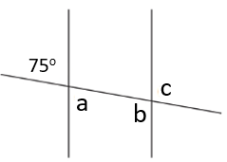

FIGURE 1

Problem 2.

Determine length ED for the similar triangles shown in Figure 2.

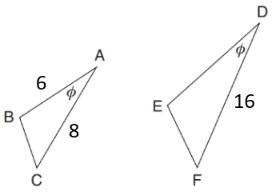

FIGURE 2

Problem 3.

Determine the resultant and indicate the angle or slope for the right-angle force system shown in Figure 3.

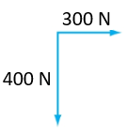

FIGURE 3

Problem 4.

Determine the horizontal and vertical components of the vector shown in Figure 4.

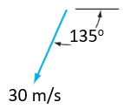

FIGURE 4

Problem 5.

Find the moment about point A for the lever shown in Figure 5.

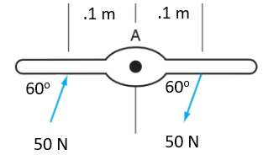

FIGURE 5